

Proudly Sponsored By Gujarat NRE Coking Coal Ltd

59th Annual Show
17th September 2011
Commences 9.00am
Bulli Showground, Princes Highway, Bulli
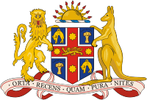
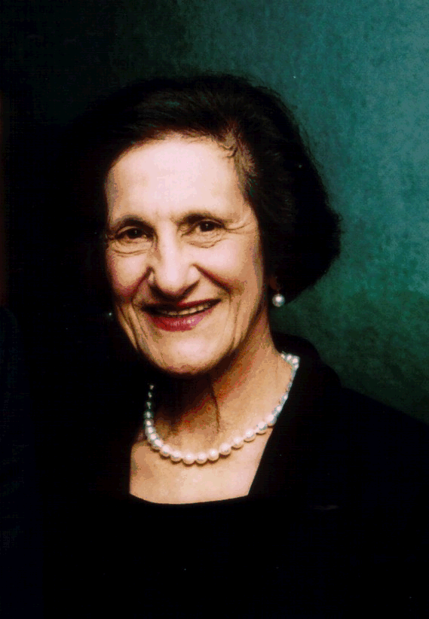

Her Excellency the Governor of NSW Professor Marie Bashir
Officialy opened the 2010 Bulli Show on Saturday 18th September .

2011 Judge Mr W Linger
All entries must be submitted before Monday 12th September
to:
The Chief Poultry Steward:

Mr. Ray Meredith
26 Hill St Bulli NSW 2516
Show Admission: Children Under 12 Free
General Admission $8, Senior Citizens $2
Poultry Section

Regulations
Entry fee: $1.00 per entry for all classes and is not refundable.
No exhibit will be accepted without entry.

All exhibits must be penned by 9am on Saturday the 17th
Judging will commence at 9.30a.m.
Stewards will be in attendance on Friday the 16th from 3.30pm to 6pm and from 7am on Saturday the 17th

Trophies and ribbons
Best soft feather large $10.00

Best opposite sex $5.00
Best hard feather large $10.00
Best opposite sex $5.00
Best soft feather bantam $10.00
Best opposite sex $5.00
Best hard feather bantam $10.00
Best opposite sex $5.00
Best soft feather large breeding pair $5.00
Best soft feather bantam breeding pair $5.00
Best hard feather large breeding pair $5.00
Best hard feather bantam breeding pair $5.00
Best waterfowl $10.00

The Committee of the Bulli Show Society Inc. would like to thank our sponsors for the kind donation of the above mentioned trophies.

Large Fowl Classes
Hard Feather Cock Hen
Australian Game Black Red 1 2
Australian Game 3 4
Indian Game Pitt 5 6
A.O.C. 7 8

O.E.G. Black Red 9
O.E.G. Black Red D/L 10
O.E.D. Partridge L/L 11
O.E.D. Partridge D/L 12
O.E.G. Wheaton 13
O.E.G. Blue Red 14 15
O.E.G. Blue Red 16 17
O.E.G. Pile 18 19

O.E.G. Duckwing Silver 20 21
O.E.G. Duckwing Golden 22 23
O.E.G. Duckwing Blue 24 25
O.E.G. Duckwing Silver 26 27
O.E.G. Duckwing Golden 28 29
O.E.G. Duckwing Blue 30 31
O.E.G. Brown 32 33
O.E.G. Grey or Birchin 34 35
O.E.G. Creole or A.O.C 36 37

Breeding Pairs Cock Hen
O.G.E. 38
Australian Game 39
Indian Game 40
Pitt Game 41
2

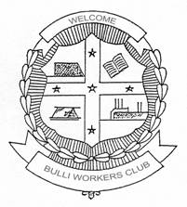
Soft Feather Cock Hen
Orpington 42 43
Australorp 44 45
Chinese Langshan Black 46 47
Chinese Langshan 48 49

Leghorn White 50 51
Leghorn Brown 52 53
Leghorn Black 54 55
Bulli Workers Club Ltd
Proud Sponsors of the
2011 Bulli Show
Leghorn A.O.C. 56 57

Wyandotte White 58 59
Wyandotte A.O.C. 60 61
Sussex 62 63
Plymouth Rock 64 65
Rhode Island Red 66 67
From The Presidents Desk

Welcome to the 2011 Bulli Show I hope this year will be a very successful year for our show.

The Governor of NSW Her Excellency Professor Marie Bashir AC CVO
to officially open the 2010 Bulli Show
Her Excellency visited the Poultry Pavilion and was very interested in the Poultry exhibits. The Governor said she grew up on a farm.

We would also like to thank our major sponsors for the wonderful support they give to the Bulli Show Society Inc.

A big thank you to our wonderful
volunteers
with out them the Show would not be possible.
Thank you to Mr Ray Meredith and his loyal workers for the wonderful work they do each year in the poultry pavilion Bulli Show Poultry Pavilion has one if not the biggest amount of entries in the area.
Also thank you the public for your support by coming along to the Show.
I hope you have a great time at the 2011 Bulli Show.

Mr John P Andrews
President Bulli Show Society Inc

Rhode Island White 68 69

Ancona 70 71

Silkie White 72 73
Silkie A.O.C. 74 75
Minora 76 77
Barnavelder 78 79
A.O.V. Soft Feather 80 81

Soft feather Breading Pair 82

Bantam Classes
Hard Feather Coch Hen
Indian Game 83 84
Australian Game 85 86
Pitt Game 87 88
A.O.V. Game 89 90

Modern Game Black Red 91 92
Modern Game Duck 93 94
Modern Game Brown 95 96
Red Grey or Birchin 97 98
Modern Game Pile or A.O.C. 99 100

O.E.G. Black Red 101
O.E.G. Clay or 102
O.E.G. Partridge L/L 103
O.E.G. Black Red 104
O.E.G. Partridge D/L 105

O.E.G. Duckwing L/L 106 107
O.E.G. Duckwing D/L 108 109
O.E.G. Blue Red L/L 110 111
O.E.G. Blue Red D/L 112 113
O.E.G. Blue Tail Wheaton 114
O.E.G. Spangle 115 116
O.E.G. Cuckoo or Creole 117 118

O.E.G. Blue or Black 119 120
O.E.G. Brown Red Grey or Birchin 121 122
O.E.G. Plie 123 124
O.E.G. White or A.O.C. 125 126
3

Breeding Pairs Coch Hen
Indian Game 127
Modern Game 128
O.E.G. 129
A.O.V. Game 130

Soft Feather Bantam
Rhode Island Red 131 132
Rhode Island White 133 134
Rhode Island Rosecombe 135 136
Leghorn White Leghorn Black 137 138
Leghorn Blue 139 140
Leghorn Brown 141 142
Leghorn A.O.C. 143 144

Langshan Black 145 146
Langshan A.O.C. 147 147
Ancona 149 150
Australorp 151 152
Sussex 153 154

Plymouth Rock 155 156
Japanese 157 158
Minorca 159 160
Sebright Silver 161 162
Sebright Golden 163 164
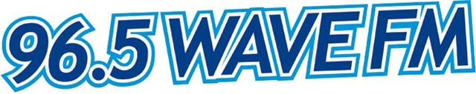
Rosecombe Black 165 166

Rosecombe A.O.C. 167 168
Pekin Black 169 170
Pekin White 171 172
Pekin Buff 173 174
Pekin Blue 175 176
Pekin Cuckoo 177 178
Pekin A.O.C. 179 180

Barnaveilde 181 182
Wyandotte White 183 184
Wyandotte Partridge 185 186
Wyandotte Silver Pencil 187 188
Wyandotte A.O.C. 189 190
Belgian 191 192
Any Other Variety 193 194

Soft Feather Breeding Pair 195
Waterfowl Drake Duck
Khaki Campbell 196 197
Indian Runner White 198 199
Indian Runner Trout 200 201
Indian Runner AOC 202 203
Muscouy 204 205
Mallard WHTE 206 207

Television

Mallard AOC 208 209
Rouen 210 211
Pekin 212 213
Silver Applyard 214 215
Elizabeth 216 217
Any other variety 218 219

Bulli Show Society Inc Poultry Section Bulli Show Society Inc Poultry Section
Secretary’s Copy
Exhibitors Copy
Class Particulars Pen
Class Particulars Pen

Entries @ $ each $
Entries @ $ Each $
Total $
Total $
All entries in A.O.C.Classes must
State colour.

Please receive above entries subject to the Rules and constitution of the club.
Name……………………………………………………...
Address……………………………………………………
…………………………………………………………….
Signature………………………………………………….
All entries in A.O.C.Classes must
State colour.

Please receive above entries subject to the Rules and constitution of the club.
Name……………………………………………………...
Address……………………………………………………
…………………………………………………………….
Signature………………………………………………….

